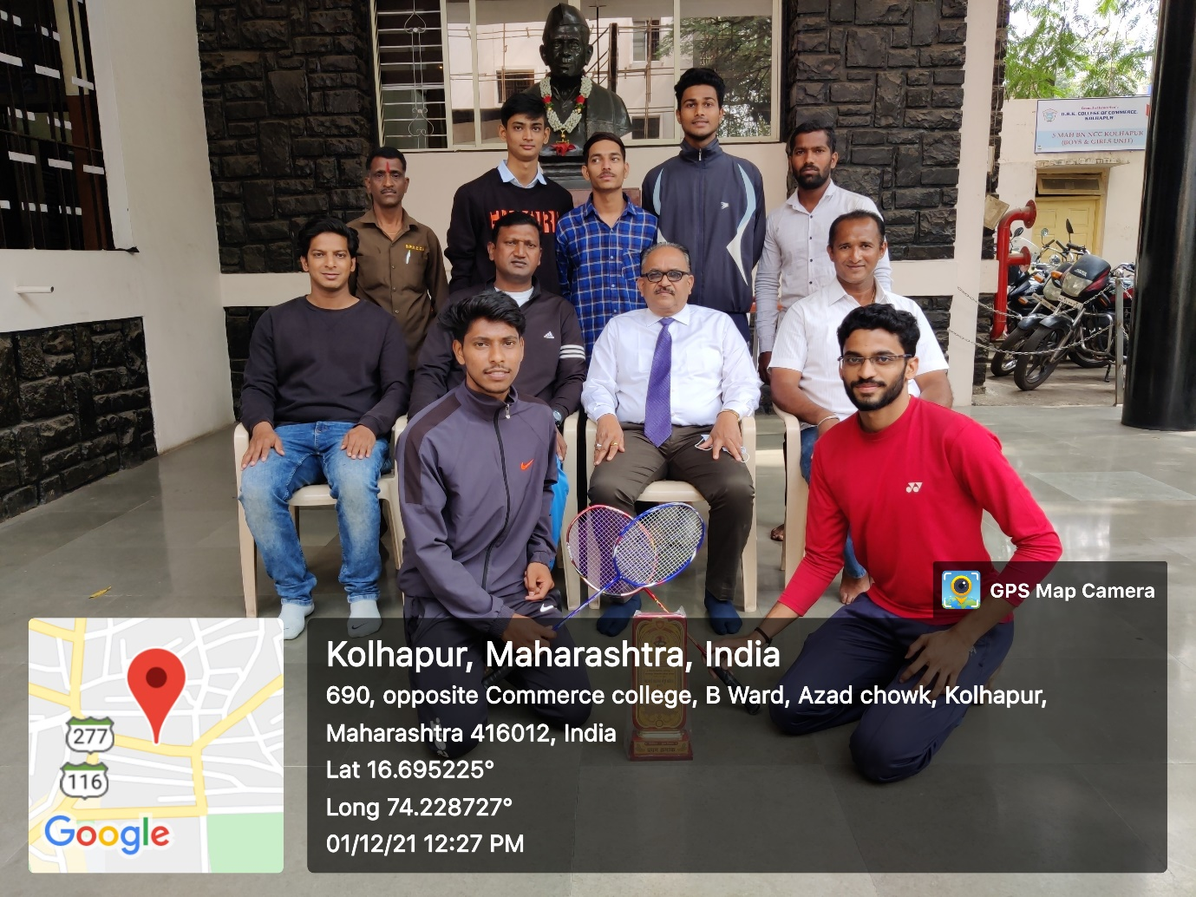
- Badminton Men team Winners at Shivaji Uni.Kolhapur Zonals & Inter Zonals with Principal Dr.V.A. Patil, Gymkhana Chairman Dr.Sharad Bansode, Shri.P.M.Patil.
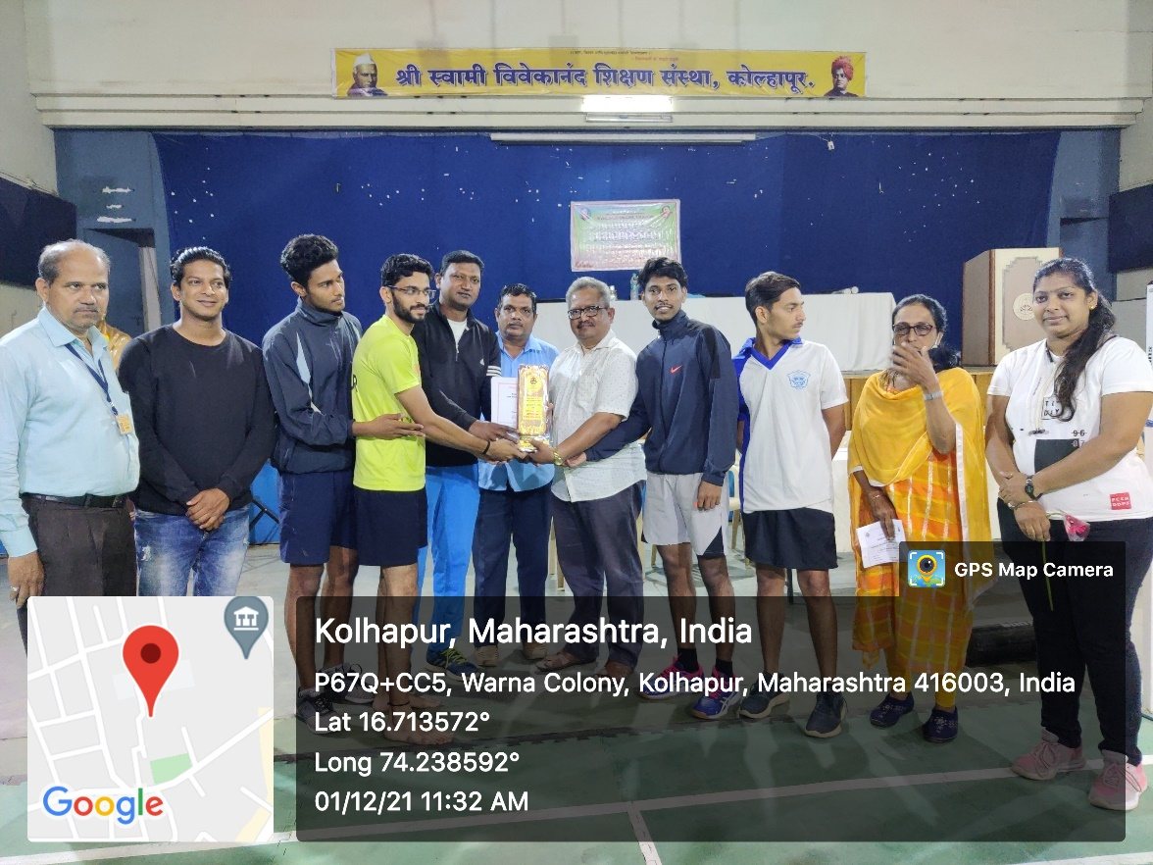
- Bandminton Team Winner of Shivaji University Kolhapur Zonal Championship 2021-22

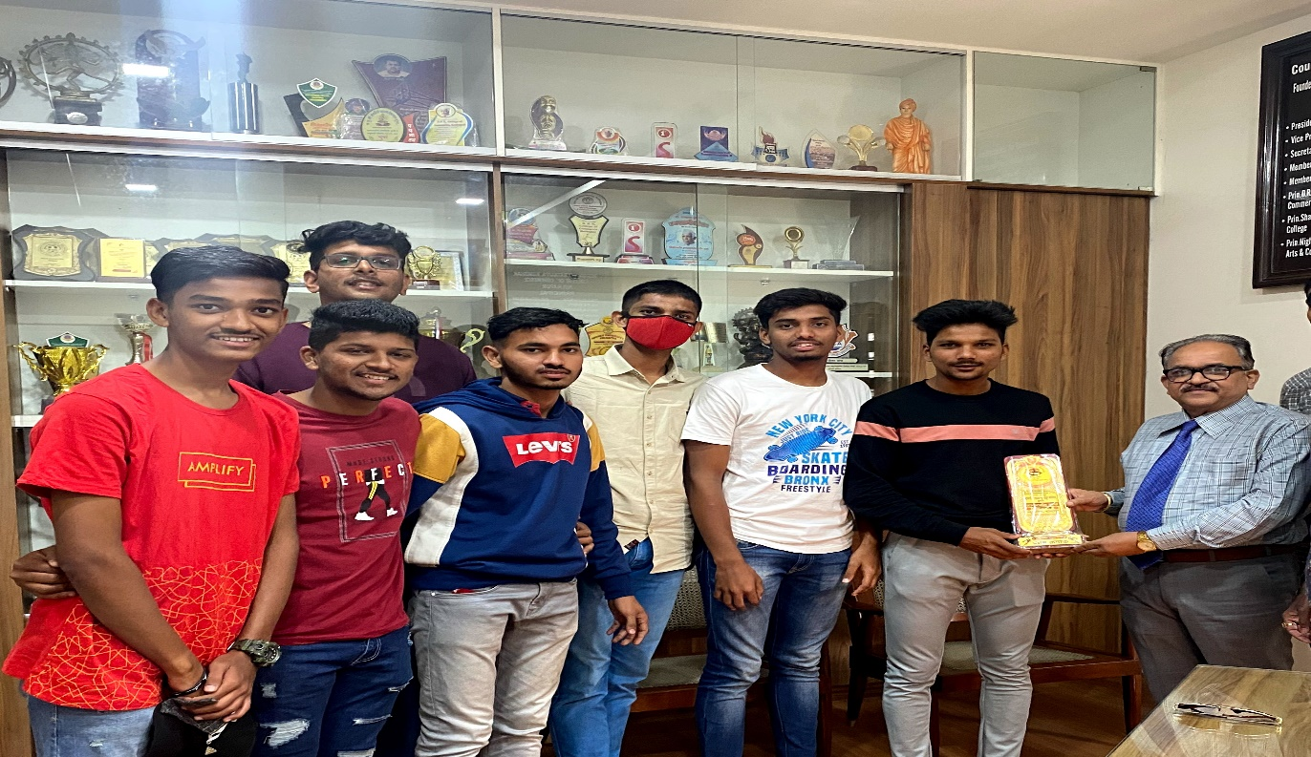
- Basketball Team Winner of Shivaji University Kolhapur Zonal Championship 2021-22
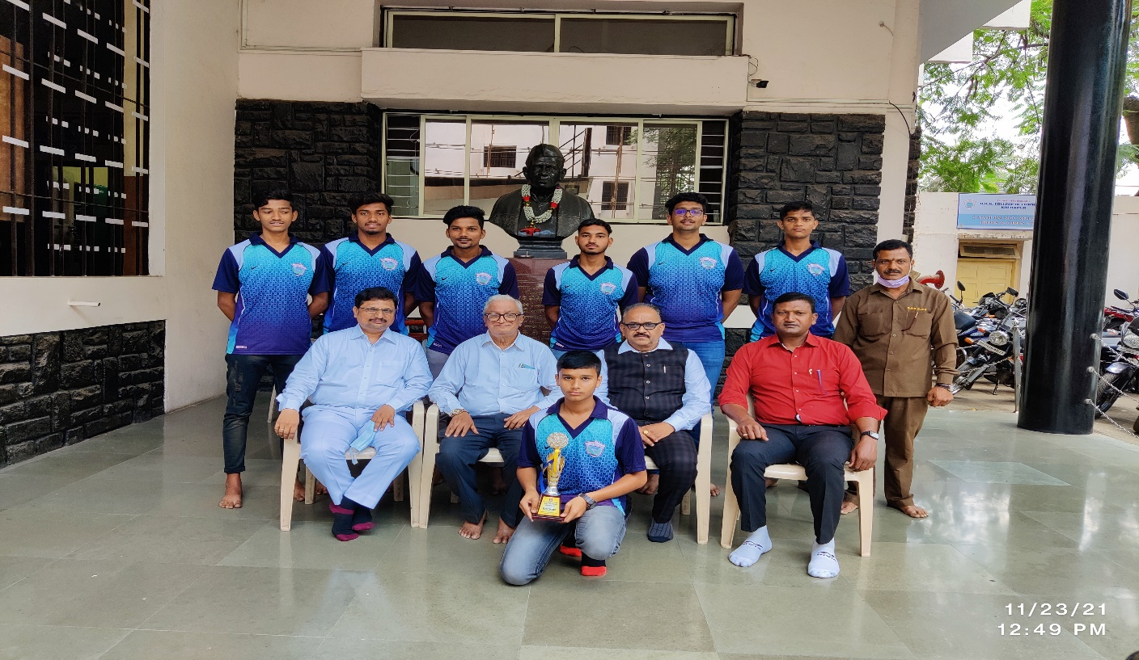

- Basketball winning team with Adv. V.N.Patil,Adv.V. Pednekar Principal Dr.V.A. Patil,Gymkhana Chairman Dr.Sharad Bansode, Basketball Team Winner of Shivaji University Kolhapur Zonal Championship 2021-22

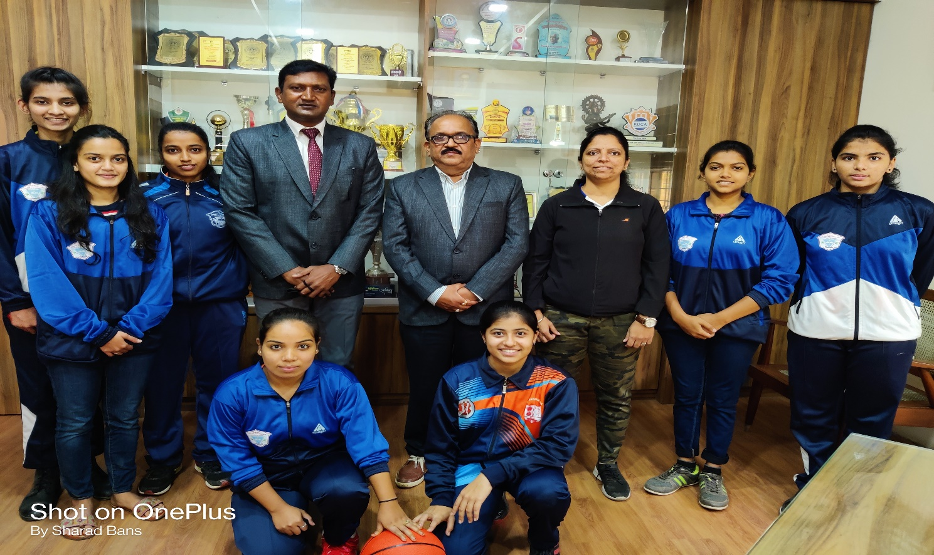
- Basketball winning team with Principal Dr.V.A. Patil,Gymkhana Chairman Dr.Sharad Bansode, Basketball Team Winner at State Championship 2021-22

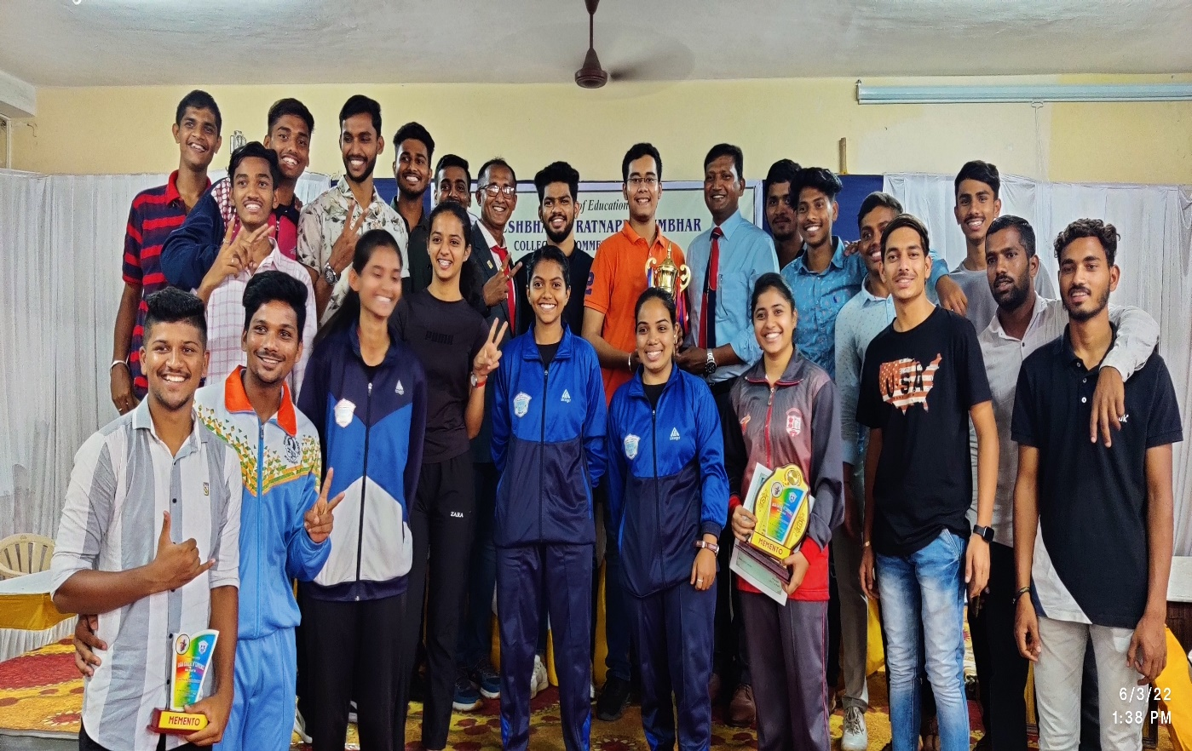

- National and University Prize winners of DRK College of Commerce at Annual Prize Distribution 2021-2022.
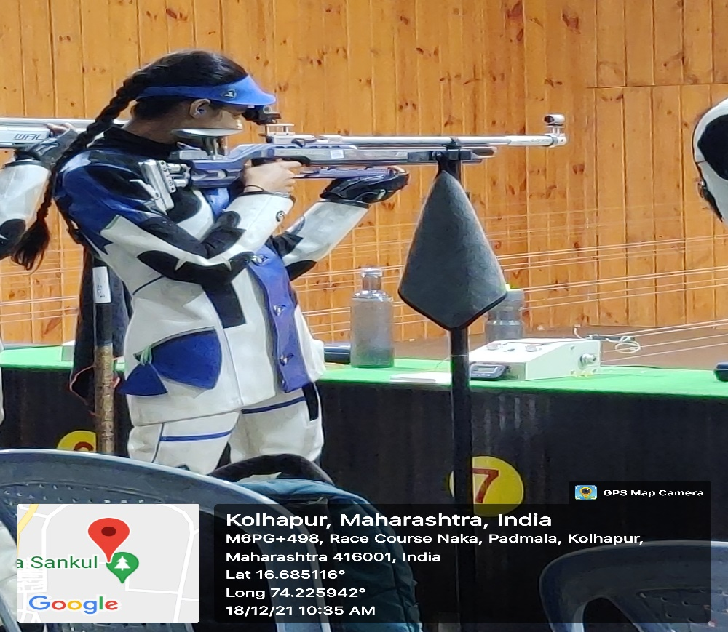
- Miss Dhumal Divya (Shooting) Selected for Nationals at Delhi with Principal Dr.V.A. Patil,Gymkhana Chairman Dr.SharadBansode.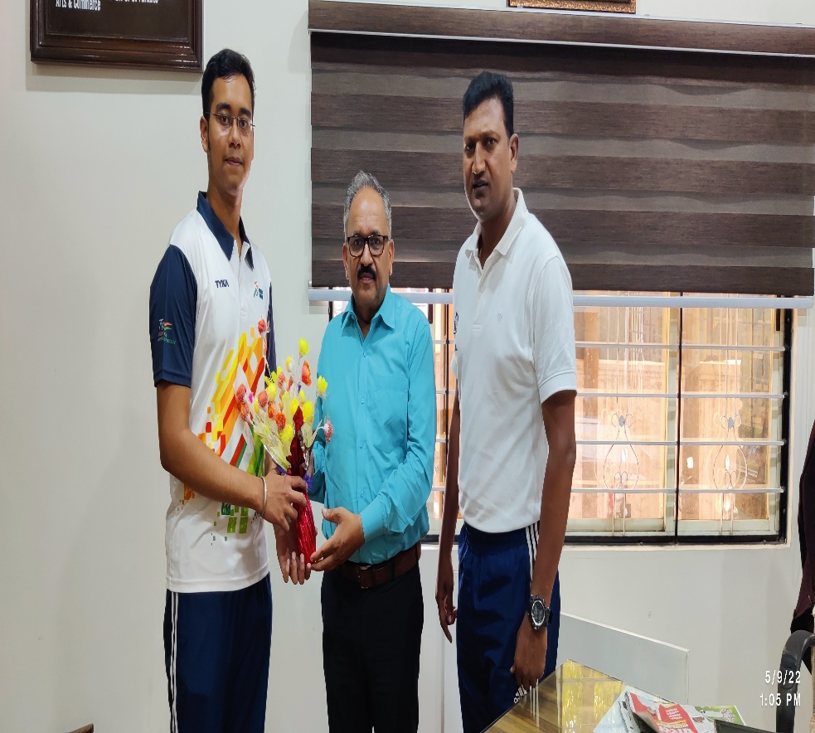
- Mr.Yash Parmale Selected for Khelo India Games at Bangalore, & selected for International Selection Trials held at New Delhi, withPrincipal Dr.V.A. Patil,Gymkhana Chairman Dr.Sharad Bansode
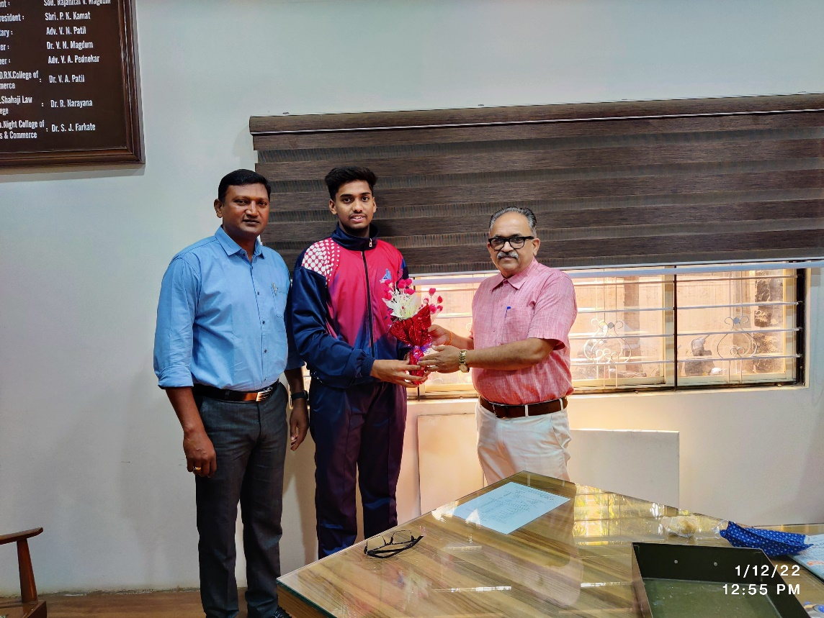
- Mr.Wasim Mulla (Basketball) Selected for Junior Nationals at Indore & member of Shivaji Uni. Inter Uni.Basketball Team with Principal Dr.V.A.Patil,Gymkhana Chairman, Dr. Sharad Bansode.

- 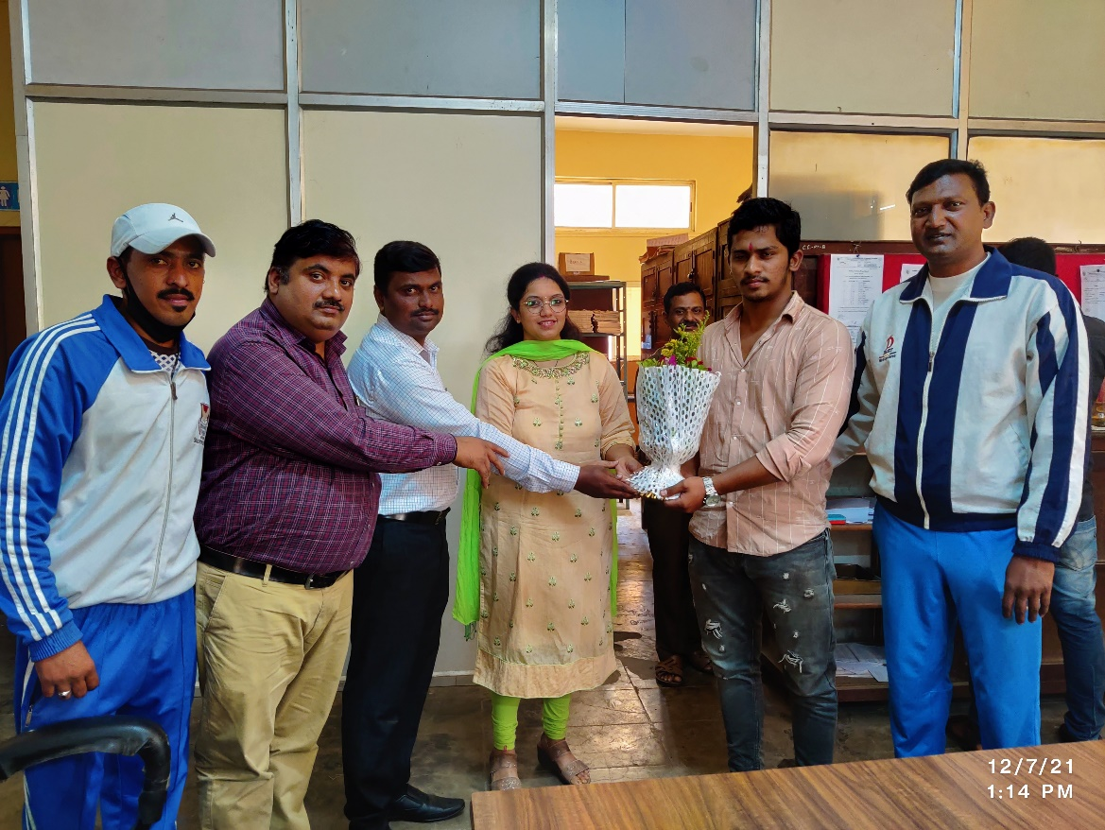Mr.Bhushan Malkar winner of Gold Medal at Shivaji University Kolhapur Zonal Wrestling Championship 2021-22.
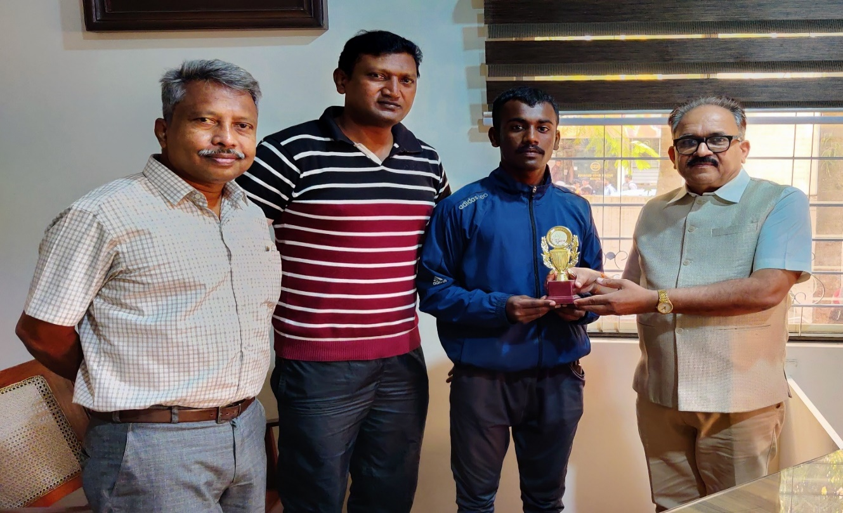
11.Mr. Abhishek Talekar Winner of Silver Medal at of Shivaji University Inter- Zonal Athletics Championship 2021-22, with Principal Dr.V.A. Patil,Gymkhana Chairman Dr.Sharad Bansode, Prof.B.T.Naik

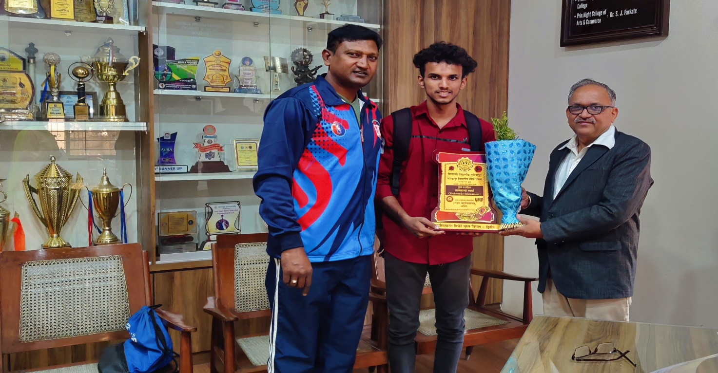
12.Mr. Pranav Pokhale Winner of Gold Medal at of Shivaji University Inter- Zonal Taekwondo Championship 2021-22, with Principal Dr.V.A. Patil,Gymkhana Chairman Dr.Sharad Bansode,
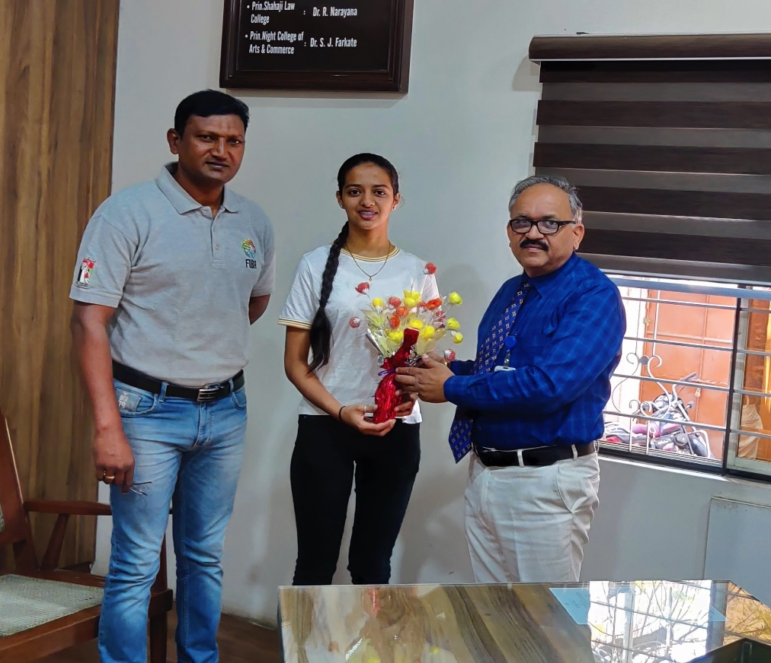
13. Miss Dhumal Divya (Shooting) Selected for Nationals at Delhi with Principal Dr.V.A. Patil, Gymkhana Chairman Dr.Sharad Bansode

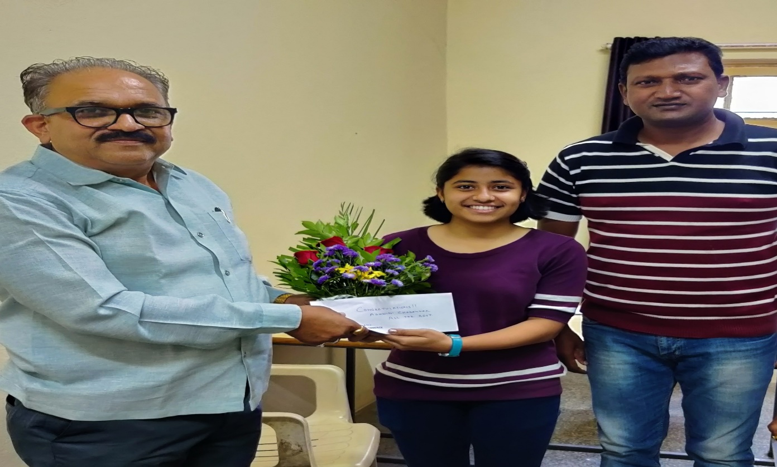
14.Miss Ashwini Charankar (Basketball) Selected for Nationals & member of Shivaji Uni. Inter Uni.Team with Principal Dr.V.A. Patil, Gymkhana Chairman Dr.Sharad Bansode

